Great wall: MP Architecture

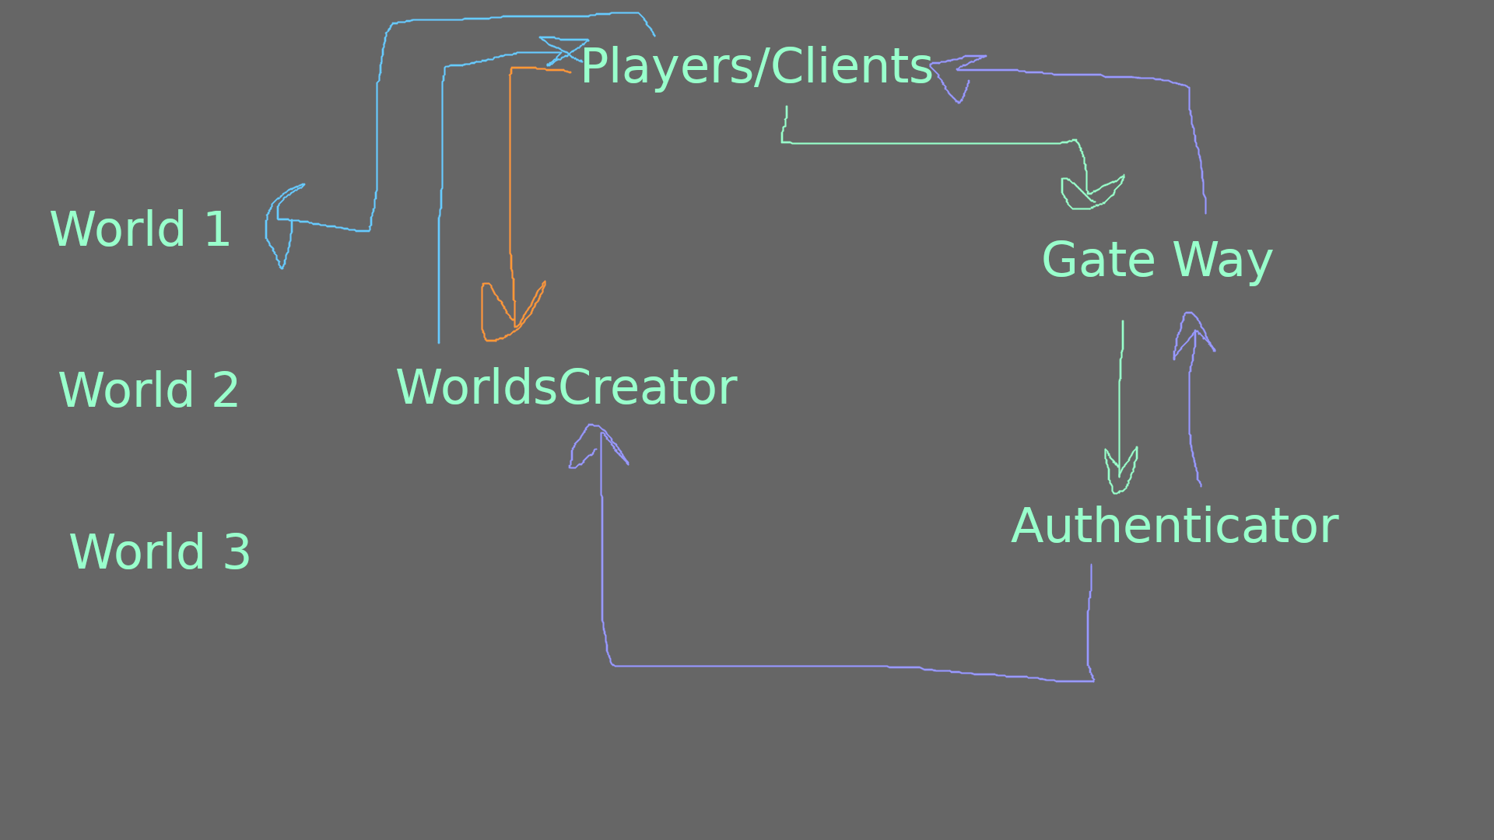
This Document, Contains Details about the target multiplayer architecture.

Required Applications/Projects:
- Client/Player
- Gateway
- Authenticator
- WorldsCreator
- Game/Match Server

Details on the process:

- Players/Clients Connect to the gate way, when they attempt log in
- Gate way: Delegates the Login Attempt from players/clients to authenticator, and returns the result to the players/clients
  - Connects to authenticator as client
  - Connects to Players as Server
- Authenticator: Sends token to WorldsCreator upon success, and sends result to Gate way.
  - Connects to Gateway as Server.
  - Connects to WorldsCreator as Server.
- Worlds Creator: Upon successful login/Token Verfication, then WorldsCreator, creates a gameworld with specified port/ip, those are sent back to the player.
  - Connects to Clients/Players as server.
  - Connects to Authenticator as client.
  - The Creation of the game world, is simply, launching the gameworld application, (An extra application, created by godot, and exported, the Worlds Creator, simply, runs that application).
- Upon Player, receiving the IP/Port of the specific game world, player/client joins that world, that world becomes the “Game/Match” Server.
- Upon the Completion of the match, Data about the match/players is sent back to worlds creator, and then delegated to authenticator, which will be used to store all data.

